

Subject: Programming with Java
ASSIGNMENT No : 4
TITLE :Develop a Java application demonstrating the use of wrapper classes for conversion between primitive data types and objects, and performing basic operations on wrapped values.

Name:Avdhoot Mohite Class:CSE
PRN:25070122056 Batch: 25-29

Problem Statement
Develop a Java application demonstrating the use of wrapper classes for conversion between primitive data types and objects, and performing basic operations on wrapped values.

Learning Objectives
To perform conversion between primitive data types and wrapper objects using Java wrapper classes.

Theory
Wrapper classes are predefined classes that encapsulate primitive data types into objects. Java provides wrapper classes such as Integer, Double, Character, and Boolean for every primitive type. They support autoboxing, unboxing, parsing, and conversion methods. Wrapper classes are widely used in Java Collections Framework and when object representation of primitive values is required

Conclusion
This experiment demonstrated the use of Java wrapper classes to convert primitive data types into objects and convert String input into numeric values. Wrapper classes are useful for validation, parsing user input, and working with collections. The Employee Payroll System showed how wrapper classes can be used in a practical application to ensure valid salary data and calculate net salary accurately.

Code and output screenshots
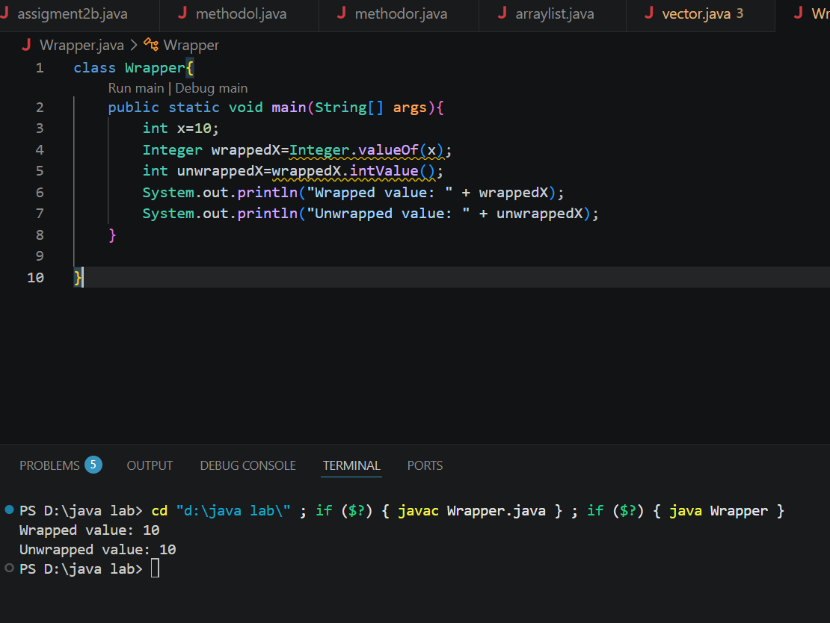

Exercise
1.Create a program to convert student marks from String format to Integer and calculate total marks. 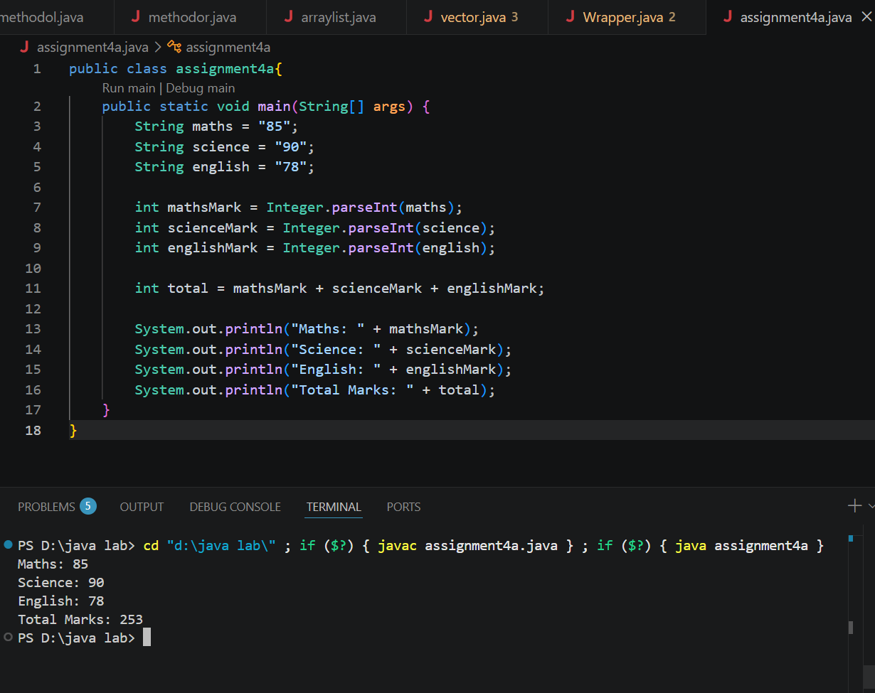

2. Develop an Employee Payroll System that accepts employee IDs, basic salary, and bonus amounts from the user. Convert the entered values into wrapper objects and perform validation operations to ensure valid salary values before calculating the net salary.
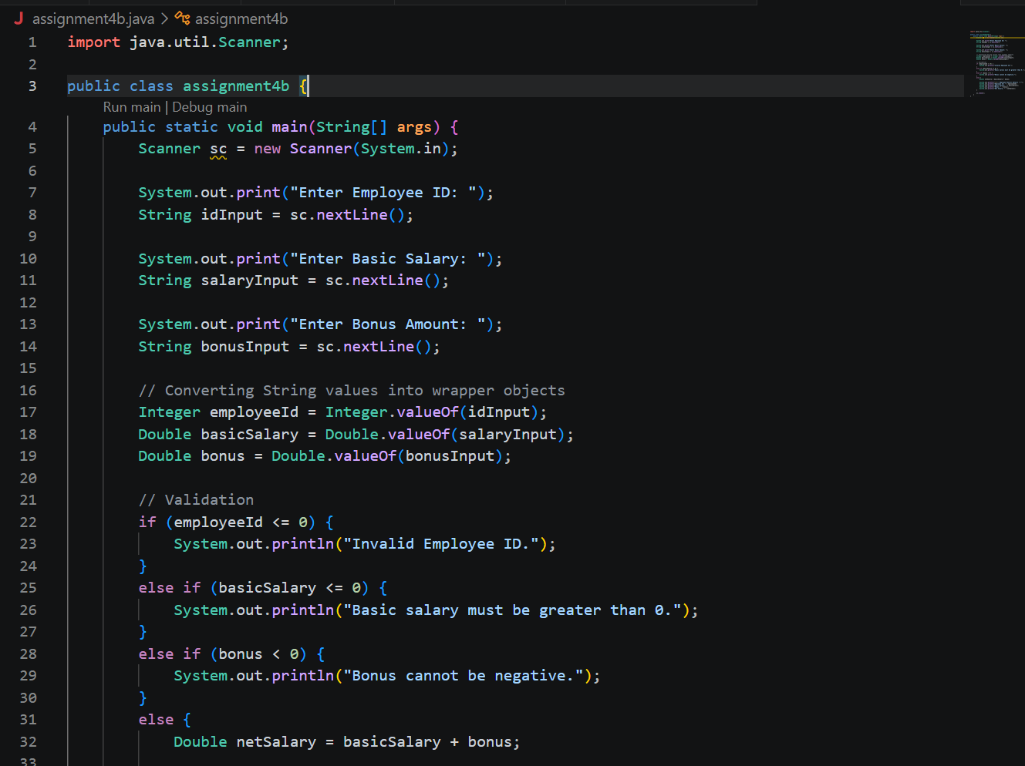
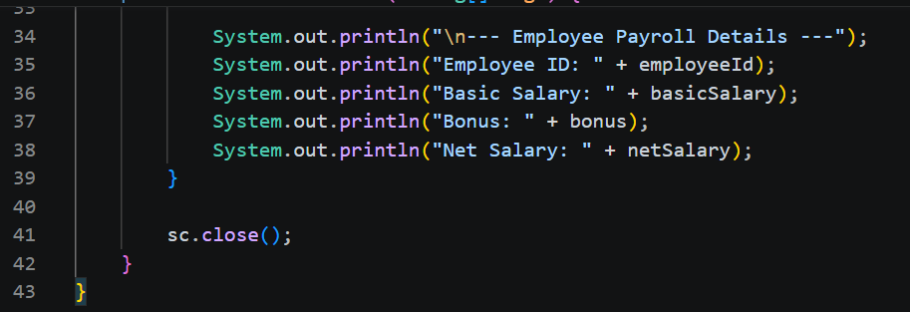
Output
